Title of the paper

John D. Brown ª, Rose Z. Nixon ^{b}

ª Institution of John D. Brown
^{b} Institution of Rose Z. Nixon
email presenting Author

Keywords: provide a maximum of 5 keywords avoiding general and plural terms and multiple concepts (avoid, for example, "and", "of").

This abstract template has been provided both to assist your submission and to ensure a uniform style throughout the booklet. Thank you for complying with the formatting provided here. You may download this template as many times as you require. To maintain the formatting of this document you can type over the text. To follow are more detailed instructions on the format. Please type the title of the abstract in sentence case. Abstracts must contain a title, author names, and their institutions. Enter the name of the presenting author first. Figures are permitted in the abstract.
The text style is as follows:
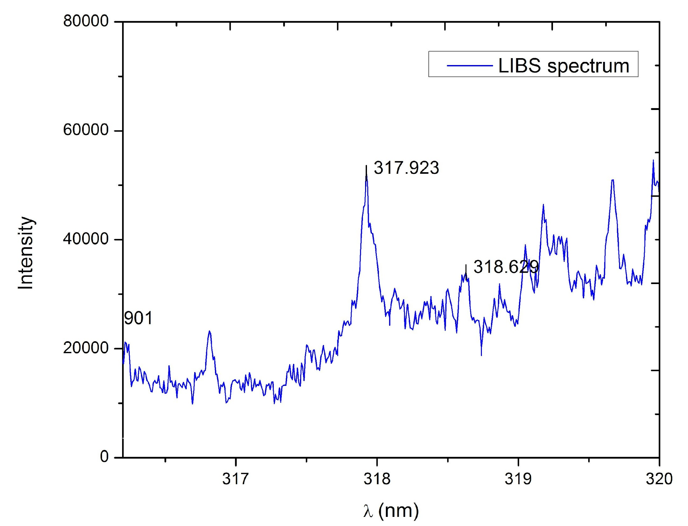
The title is Arial, 16pt, left aligned, 6pt spacing before and after, single spacing between each line; the author name is Arial, 11pt, left-aligned, 6pt spacing before and after, single spacing between each line, last name then first name in full; the Institution is Arial, 11pt, left-aligned, italic, 6pt spacing before and after, single spacing between each line; all body text is Arial, 11pt, justified, 24 spacing before and after each paragraph and 12pt spacing between each line; the references are Arial, 9pt, left-aligned, 0pt spacing before and after. References should be superscripted numbers (e.g. ¹) and follow a numerical order of appearance in the text. References should be formatted in the style given below. Please ensure your abstract is no more than one page, including figures and references.
Figure should have a caption in Arial 8 point font.

Figures should have a caption and be readable, i.e. caption in Arial 8 point font and figure labels in Arial 6 or 9 point font. Figures may be in colour.

References for paper (example [1]) and books (example [2]):

[1] C. Sánchez-Aké, T. García-Fernández, J. L. Benítez, M. B. de la Mora, M. Villagrán-Muniz, Intensity enhancement of LIBS of glass by using Au thin films and nanoparticles, Spectrochim. Acta B 146 (2018) 77-83. https://doi.org/10.1016/j.sab.2018.05.007
[2] T.H. Martin, W. Bruggenwert, Composition of the Soil, Soil Chemistry A. Basic Elements, Elsevier Scientific Publishing Company, 1978.

